# Chapter 2: Financial Math

### Exercises 2.1

Use a spreadsheet to compute the following.

1. Convert 4/7 to a decimal
2. Convert 16% to a decimal
3. Add 8 and 19
4. Find the difference of 230 and 78
5. Multiply 12 and 9
6. Divide 0.09 by 52
7. Calculate 83
8. Your bill at a restaurant is $55.75 and you want to leave a 20% tip. How much would you add to the bill?
9. You leave a tip for $7.50 for a bill at a restaurant that is $44.50. What percent tip did you leave?
10. In Column A use the fill down feature to build a spreadsheet starting with $5 and ending at $125, in increments of $5. In Column B write a formula with a cell reference to calculate a 15.5% tip on the amount in Column A. Use the fill down feature to complete your table.
11. Imagine a certain savings account started out with a balance of $5250.00 on day-one, and today has a current balance of $5780.23.
12. Exactly how much more money does the account have today, compared with day-one?
13. Rounding to the nearest tenth of a percent: By what percentage amount has the account balance grown?
14. If instead, the bank balance today was exactly double the starting balance, then by what exact percentage amount would the bank balance have grown?
15. If the bank balance today had instead grown by 15.5% since day-one, then what would be the exact amount of today’s balance? ADD
16. Imagine that at the start of a certain month, you will make an opening deposit of $500 into a savings account, and you will then leave the account alone (meaning you will make no further deposits or withdrawals). Also, for this account: Every month after the

opening deposit, the amount in the account will grow to be 101% of its previous month’s balance.

1. Use a spreadsheet to enter 500 in cell A1. Using a formula and a cell-reference: Compute in cell A2, the amount in the account after one month has passed. Then using the fill down feature, continue the pattern for another eleven full months (you should end at cell A13). Format all the cells to show dollar signs. What is the amount in the account after one year?
2. Now continue the pattern in column A of your spreadsheet to extend for a second full year (you should end at cell A25). What is the amount in the account after two years?
3. What overall percentage growth occurred in the account between the opening deposit and one year later? (Compute using a formula and cell references)
4. What overall percentage growth occurred in the account between the end of year one, and the end of year two? (Compute using a formula and cell references)
5. (Challenge) The annual percentage growth that you found in part (d) for the second year, should be identical to the annual percentage growth that you found in part (c) for the first year. Can you mathematically explain why this is true? Do you think this pattern of identical overall annual percentage growth would continue, if you extend the pattern for even more years? ADD
6. Imagine that at the start of a certain year, you will deposit $1000.00 into a savings account, and then you will leave the account alone. Each year after the opening deposit, the amount in the account will grow to be 103% of its previous year’s balance.
7. After two years, the account balance will have experienced two growth amounts of 103%. You can find this account balance amount here, with the spreadsheet computation = 1000 * (103%) * (103%). Perform this computation in a spreadsheet and write the balance that you find.
8. Now enter the spreadsheet computation = 1000 * (103%)^2. Notice that the result here, which involves using a power, gives the same answer as you found in part (a). Comparing the two spreadsheet computations: Explain why they give the same result.
9. Using the pattern in part (b) above, and carefully choosing the power: Compute the balance that will be in the account fifteen full years after the account was originally opened. (Round to the nearest cent)
10. (Challenge) Make a spreadsheet that shows the account balance each individual year for 30 years. From the date of the opening deposit: What minimum number of full years will you have to wait, until the balance finally exceeds twice its opening deposit amount? (Use cell references, the fill down feature, and dollar formatting)
11. (Challenge) Imagine the opening balance of the account was $5000.00 instead of $1000.00 (and everything else about the account stays the same). Make a similar spreadsheet as you did in part (d), and using this spreadsheet, find the minimum number of full years you will have to wait this time, until the balance finally exceeds twice its opening deposit amount. How does this answer compare with your answer in part (d)? Do you think your answer would be the same here, for any positive opening balance you may choose for the account? ADD

**Answers for Exercises 2.1**

(Note: Spreadsheet input is shown in a cell box if viewing in Microsoft Word)

1. = 4/7 which gives approximately 0.571429
2. = 16% which gives 0.16
3. = 8 + 19 which gives 27
4. = 230 – 78 which gives 152
5. = 12 * 9 which gives 108
6. = 0.09 / 52 which gives approximately 0.001731
7. = 8 ^ 3 which gives 512
8. = 55.75 * 20% which gives 11.15, or eleven dollars and fifteen cents
9. = 7.50 / 44.50 which gives approximately 0.168539, or approximately 16.8539%
10. See Table 1 at right:

Note, the entry in cell B1 is = 15.5% * A1  **Table 1**

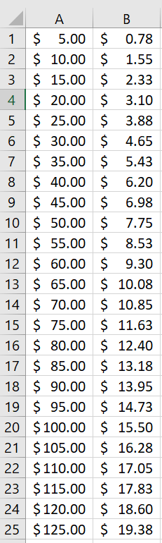(Columns A and B are given dollar formatting)

1. **a)** = 5780.23 – 5250 which gives 530.23 dollars

**b)** = 530.23 / 5250 which gives approximately 0.100996, or approximately 10.1%

**c)** Exactly 200%

**d)** = 5250 * 115.5% which gives exactly 6063.75 dollars

1. For parts **(a)** and **(b)**, see Table 2 at right: **Table 2**

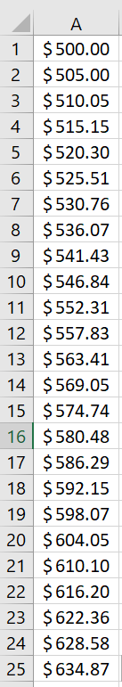After 1 year, the account holds $563.41

After 2 years, the account holds $634.87

**c)** = A13 / A1 which gives ≈112.6825% growth

**d)** = A25 / A13 which gives ≈112.6825% growth (same)

**e)** Each starting value increases mathematically by a factor of

(1.01)^12 each year, which is ≈112.6825%. So yes, this

pattern must continue indefinitely into future years.

1. **a)** = 1000 * 103% * 103% which gives 1060.90 dollars.

**b)** = 1000 * (103%)^2 gives the same result of 1060.90 dollars.

because raising 103% to the second power means the same as

multiplying 103% by itself two times.

**c)** = 1000 * (103%)^15 which gives 1557.97 dollars (to the nearest cent).

For parts **(d)** and **(e)**, see Table 3 at right: **Table 3**

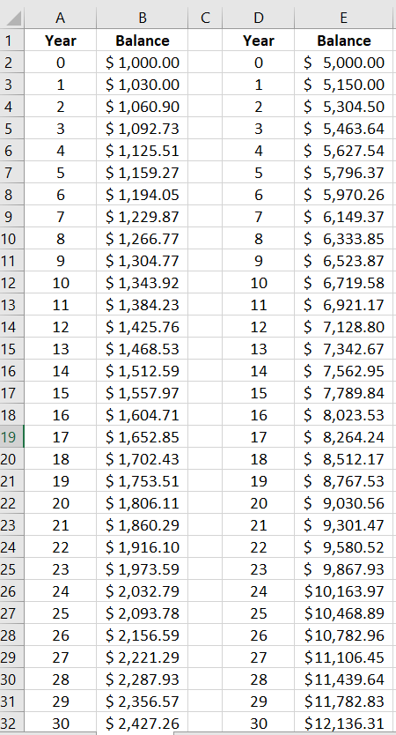

Note the entry in cell B3 here is

= B2 * 103%

and the remaining cells are computed

using the fill down feature.

You will have to wait a minimum

of 24 full years, in each case, in order

for the balance to finally exceed twice

the opening deposit amount.

Since (103%)^23 < 2 < (103%)^24,

the minimum number of full years

until the opening deposit doubles

must be the same here, for any positive

opening balance that we may choose

for this account.